**Oklawaha Greenway Summer – Non-native & Invasive Species Scavenger Hunt**

Check the box for each species you can find.

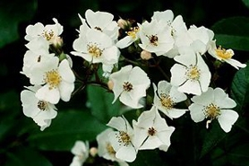

Multiflora Rose (***Rosa cathayensis*)**

Invasive shrub with sharp cat-claw like thorns that point down the branch. Can grow up to 15 ft tall. Green oval leaflets that are alternate and compound.

Crowds out native plants and can produce up to 1 million seeds per plant!

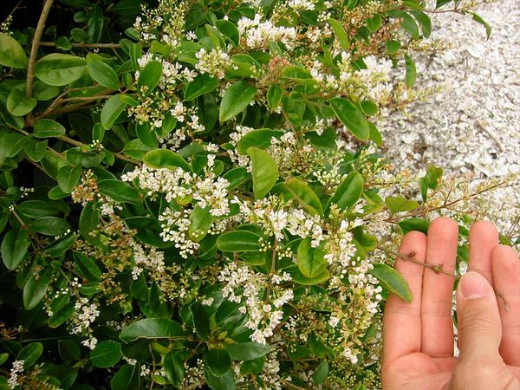

Privet (*Ligustrum lucidum*)

Evergreen tree – has a dense canopy of bending branches composed of leaves that are opposite of each other, oblong, and leathery. Flowers are produced in large clusters and are small, cream-colored and strongly scented.

Spreads quickly and will dominate an area.

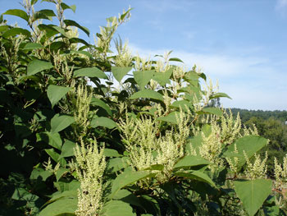

Japanese Knotweed (*Fallopia japonica*)

Dense growing shrub reaching heights of up to 10 feet. Has a semi-woody stem with alternating leaves. Flowers in late summer with small, greenish-white flowers develop in long panicles in the axils of the leaves.

Grows thick, blocking sun for other plants. Persistent and hard to get rid of without herbicide.

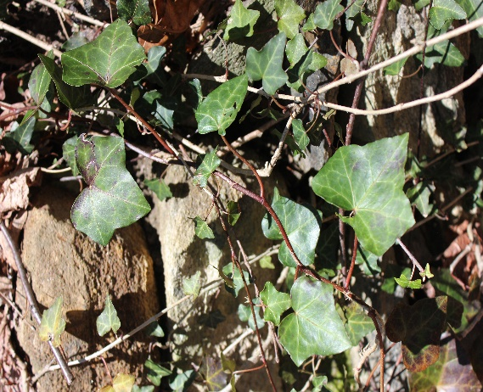

English Ivy (*Hedera helix*)

Evergreen vine that likes to grow up trees, fences, and walls. The leaves are dark green with light green to white veins.

Will engulf and kill trees.

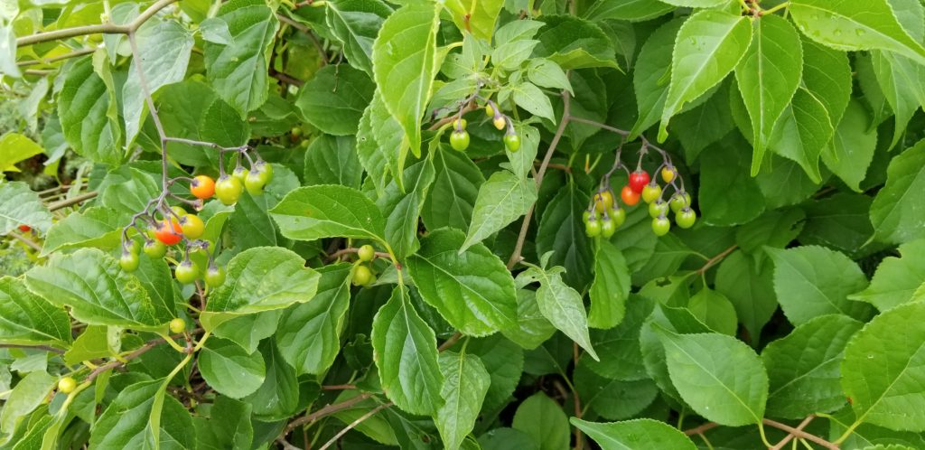

Challenging Find

Bittersweet (*Celastrus orbiculatus)*

Gray, woody vine with alternating, elliptical to circular leaves are light green. Develops small round fruits in the summer – that are green when young that ripen to yellow/red. Vines can get up to 4 inches thick and grow to lengths of 60 feet.

Grows rapidly, climbing around trees – girdling them, eventually killing them or causing breakage due to the weight of the vines.