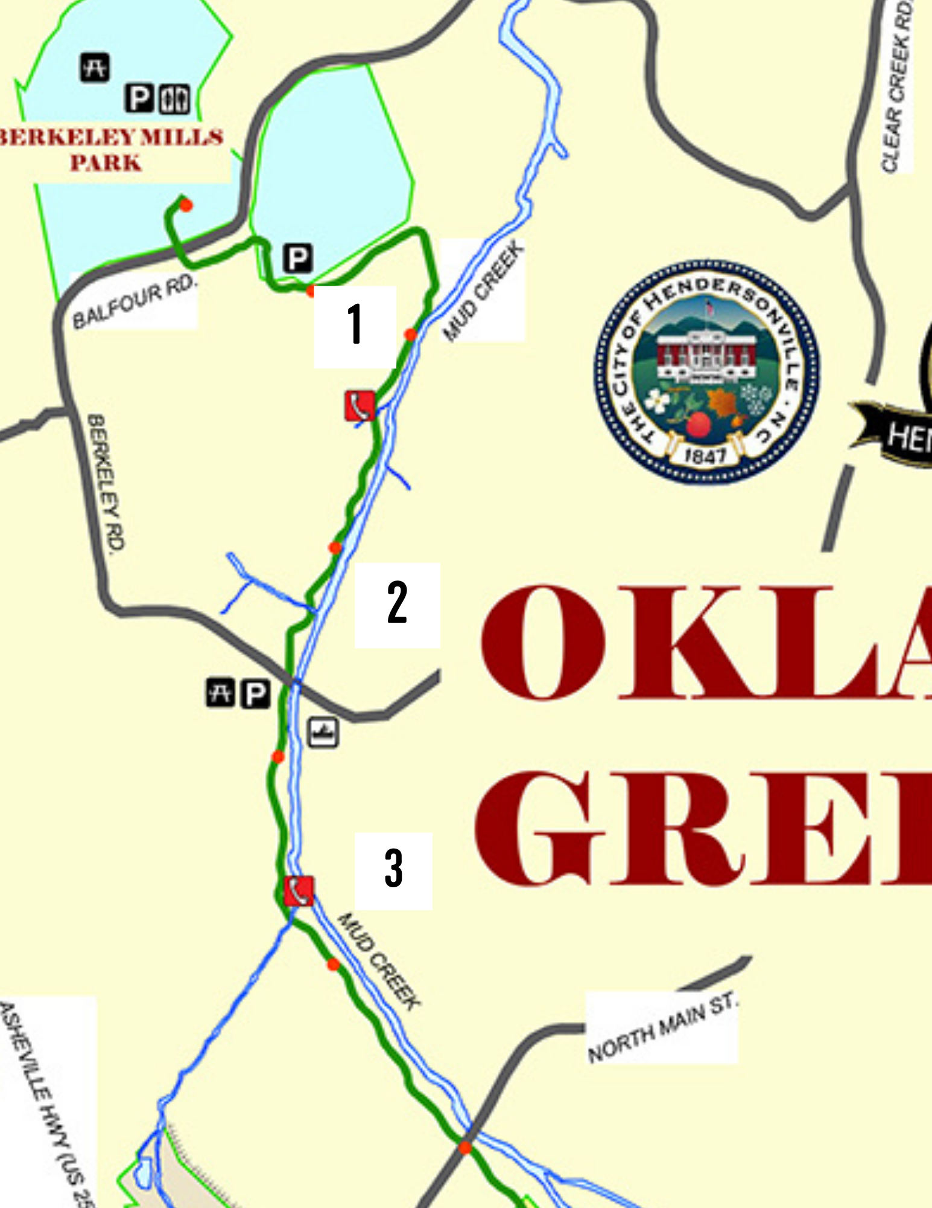

Oklawaha Greenway Summer
Non-native & Invasive Plant Key

- Section 1 – Finds
  - Chinese Privet (Ligustrum lucidum)
  - Multiflora Rose (Rosa cathayensis)
  - Bittersweet (Celastrus orbiculatus)
  - Japanese Knotweed (Fallopia japonica)

- Section 2 – Finds
  - Multiflora Rose (Rosa cathayensis)
  - Japanese Knotweed (Fallopia japonica)
  - Chinese Privet (Ligustrum lucidum)
  - Bittersweet (Celastrus orbiculatus)

- Section 3 – Finds
  - English Ivy (Hedera helix)
  - Multiflora Rose (Rosa cathayensis)
  - Japanese Knotweed (Fallopia japonica)
  - Chinese Privet (Ligustrum lucidum)

Why are Non-native & Invasive Plants Harmful?

Habitat loss and non-native and invasive plants are the leading cause of native biodiversity loss. Non-native and invasive plant species spread quickly and can displace native plants, prevent native plant growth, and create monocultures. A healthy plant community has a variety of herbs, shrubs, and trees. Non-native and invasive plants cause biological pollution by reducing plant species diversity. Changes in plant community diversity reduce the quality and quantity of wildlife habitat.

Oklawaha Greenway Non-native and Invasive Plant Scavenger Hunt Leader Questions

- Can you explain what a non-native and invasive plant is and why it is harmful?
- What did you learn about plants?
- Do you think learning how to identify plants is important?
- How do you think you can use the information you learned today in the future?
- Can you name one non-native and invasive species? How can you identify it? And how it effects the environment around it?

