**Norman Wilder Forest –**

**Non-native & Invasive Species Scavenger Hunt**

Check the box for each species you can find.

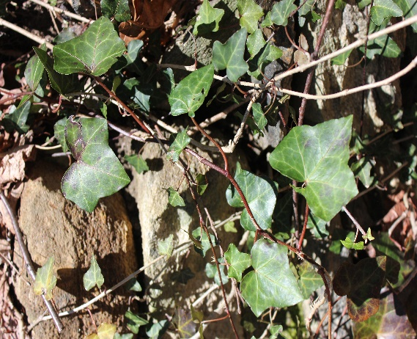

English Ivy (*Hedera helix*)

Evergreen vine that likes to grow up trees, fences, and walls. The leaves are dark green with light green to white veins.

Will engulf and kill trees.

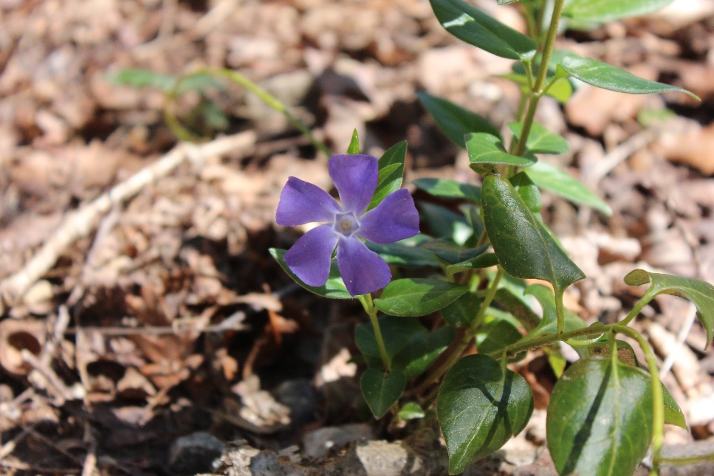

Periwinkle (*Vinca minor*)

Evergreen to semievergreen trailing vine that reaches up to 6 feet long. The vine is slender and green with opposite, glossy leaves. Violet to blue flowers with five petals.

Will take over an area, forming dense and extensive mats along the forest floor pushing native plant species out.

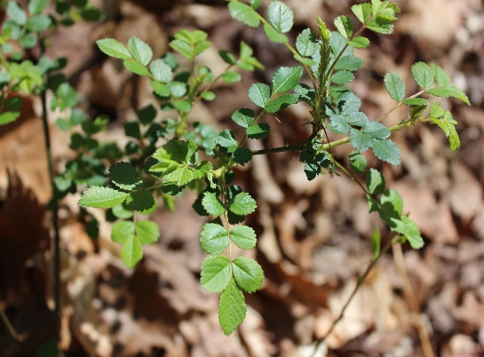

Multiflora Rose (***Rosa cathayensis*)**

Invasive shrub with sharp cat-claw like thorns that point down the branch. Can grow up to 15 ft tall. Green oval leaflets that are alternate and compound.

Crowds out native plants and can produce up to 1 million seeds per plant!

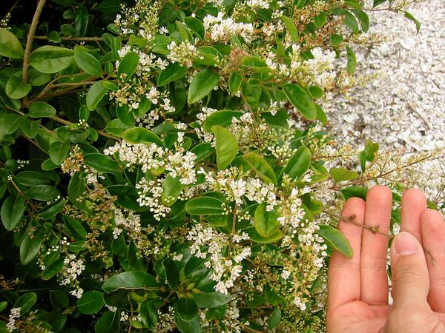

Privet (*Ligustrum lucidum*)

Evergreen tree – has a dense canopy of bending branches composed of leaves that are opposite of each other, oblong, and leathery. Flowers are produced in large clusters and are small, cream-colored and strongly scented.

Spreads quickly and will dominate an area.

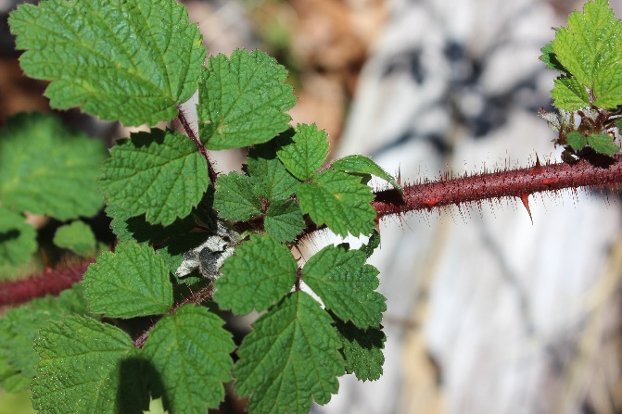

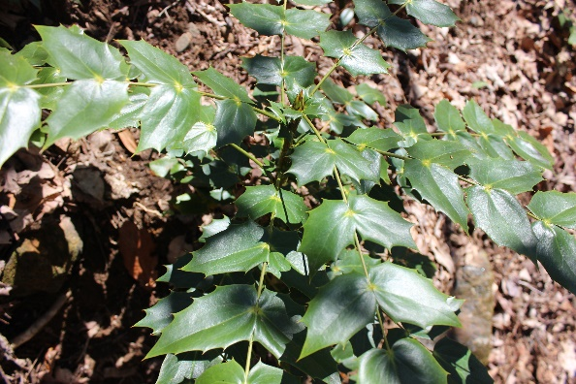

Wineberry (*Rubus phoenicolasius*)

Berry producing shrub with reddish stems, covered in spiny hairs. Leaves are alternate and divided into three leaflets with toothed margins.

Will take over an area, pushing native plant species and creating uninhabitable spaces for native animal species.

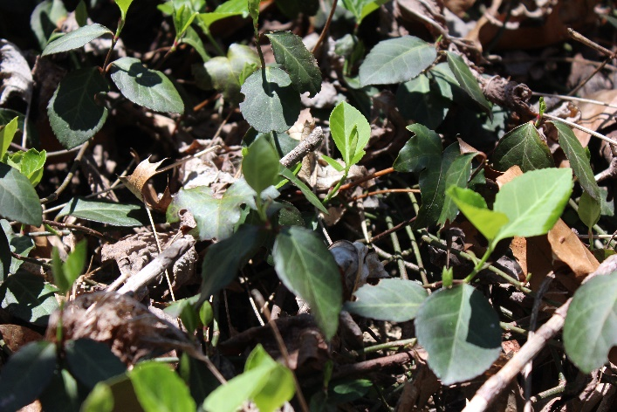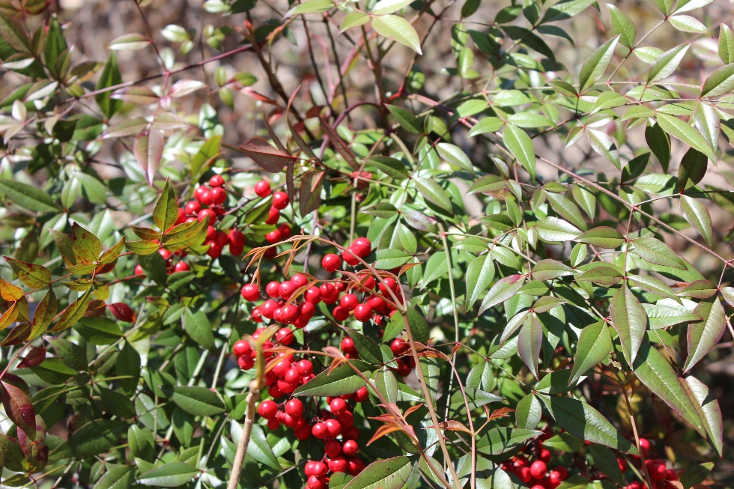

Winter Creeper (*Euonymus fortune*)

Vigorous evergreen, woody vine that invades forest openings. It has opposite leaves that are dark green, oval, slightly toothed, with light-colored veins.

Grows across the ground, displacing native species.

Heavenly Bamboo (*Nandina domestica*)

Evergreen shrub that can grow up to 4-8 feet. With bright red berries, this shrub has compound leaves that resembles bamboo leaves, giving it its name.

Reproduces from both roots and seeds and displaces native species. Leaves and berries are also toxic to livestock, birds, and other animals.

Challenging Finds

Oregon Grape (*Mahonia aquifolium*)

Evergreen, bushy shrub with shiny, spiky leaves that resembles holly. Produces blackish-blue, unpleasant tasting, edible berries, that look like very small grapes.

Crowds out native plants.