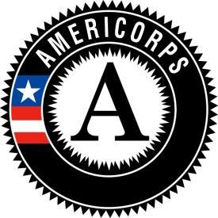
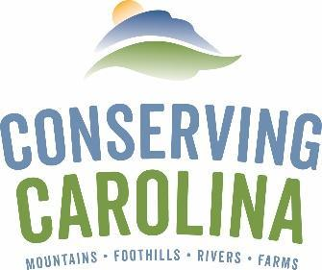
AmeriCorps Project Conserve
2021 – 2022 Service Description

AmeriCorps Position Title: Education Associate
Host Site: Organic Growers School

Supervisor Name: Cameron Farlow
Supervisor Title: Executive Director
Supervisor Email: cameron@organicgrowersschool.org

Physical Address: 38 Hawk Hill Rd. Asheville, NC 28806
Mailing Address (if different): P.O. Box 17804 Asheville, NC 28816

Phone: (828) 214-7833
Fax:
Website: https://organicgrowersschool.org/

Host Site Mission Statement:

Organic Growers School (OGS) inspires, educates, and supports people to farm, garden, and live organically. OGS is the premiere provider of practical and affordable organic education in the Southern Appalachians, building a vibrant food & farming community by boosting the success of organic home growers and farmers in our region.

Summary of Position:

The Education Associate will expand OGS’s conservation education opportunities. The member will develop, plan, organize, and facilitate virtual and in-person education for home-growers, community gardeners, and farmers. This position will be crucial in helping to educate the community about implementing organic and sustainable growing practices, as well as the importance and necessity of organic farming and gardening to the long-term health and conservation of our environment and community.

Qualifications – Knowledge, Skills, and Abilities:
- Ability to work with diverse groups of people, and speak in public.
- Strong communication and people skills. Able to engage and relate with people from all backgrounds.
- Strong verbal and written communication skills.
- Experience with using livestreaming and other emerging communication technologies.
- Highly organized and able to see both the big picture and work with details.
- Excellent time-management, multi-tasking, and prioritization skills.
- Able to learn quickly.
- Self-motivated and able to take initiative in working independently.
- Able to easily cooperate with a team.
- Innovative. Creative. Flexible.
- Experience with some or all of the following is preferred: Asana, Google Suite, Wordpress, Zoom, Social Media.
- Familiarity with sustainable food, farming, gardening and/or non-profit organizations a plus.
- Eligible applicants must be at least 18 years of age, be a citizen, national, or lawful permanent resident alien of the United States, and consent to a criminal history check.

Preferred Service Hours / Weekly Schedule:
35 hours/week, typically Monday – Friday, 9 – 5 pm. However, we do offer some flexibility in scheduling for all staff due to the fact that this position will require working some evenings and weekends as class and training times are scheduled to serve participants with day-jobs.

PLEASE NOTE: In addition to fulfilling host site service responsibilities, all Project Conserve members are required to fully participate in team trainings, service projects and statewide AmeriCorps events. Project Conserve team events will occur approximately twice per month in locations throughout the service area and may require one or two overnight stays.

Position Responsibilities and Duties:

CONSERVATION EDUCATION: 100%

- Support OGS Home Grower Programs:
  - Develop, plan, organize, and facilitate a series of online home-grower webinars throughout the summer along with community partners.
  - Assist with organizing and implementing the Homestead Dreams workshop, and the annual Gardening Series.
  - Interface with Home Grower program speakers and manage educational content creation.
  - Assist with educational video and online educational content creation for home growers.
  - Explore opportunities for growth, expanding educational opportunities, funding, and partnerships for Home Grower programs in coordination with the Programs Team.
- Support OGS Farmer Programs:
  - Assist with organizing and facilitating the CRAFT Farmer Network which includes a series of on-farm trainings for aspiring, beginning and experienced farmers in organic and sustainable crop production, livestock management and forest crops.
  - Assist with blog posts, photography and videos highlighting CRAFT tours within the farmer network.
  - Provide one-on-one support to farmer and apprentice members.
- Give community presentations, staff exhibit booths at partner events, and provide information to community members and partners about the importance of organic and sustainable farming and gardening practices for natural resource conservation and protection, as needed.
- Participate in year-round planning, systems changes and strategies, timeline flows, and management of team and shared roles, as needed.
- Engage with all other Programs & Outreach staff for smooth and effective team management.

ESSENTIAL FUNCTIONS

- Equipment / Software Used: Computer, Asana, Google Suite, Wordpress, Zoom, Social Networking platforms, videography editing software
- Physical Demands: Member should be comfortable leading people in the field in sometimes adverse conditions and potentially steep terrain (if in-person events are possible.)
- Transportation Needs: An eligible associate must have their own vehicle that they can use. Although the position does not require a great deal of travel, the location of OGS’s office is in West Asheville. The AmeriCorps member may need to visit other farm and garden properties in the landscape for in-person or video program events across the WNC region.
- Setting/Location of Service Activities: Asheville, NC and surrounding WNC counties. During the pandemic work is primarily remote.
- Other Essential Functions:
  - Using computer software and online programs for conservation-based education and outreach initiatives, including social networking, written articles and press releases.
  - Leading, coordinating, and interacting with diverse individuals in field-based and office settings (ex. landowners, students, low-income residents, partner organizations).
  - Developing and implementing educational programs and events for groups (presentations, workshops, educational hikes and outings, etc).
  - Training, supporting, coordinating, and recognizing volunteers for conservation-based volunteer opportunities.

