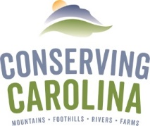
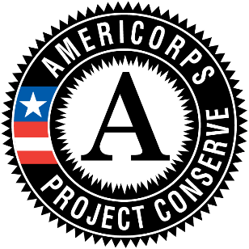
AmeriCorps Project Conserve
Member Application 2020-2021
COVER SHEET
Extended Deadline: June 15, 2020

For questions, please contact Amy Stout at
828-697-5777 ext. 217 or projectconserve@conservingcarolina.org

Your Legal Name: Click to enter text. Nickname: Click to enter text.
Date of Birth: Click to enter text.

SURVEY

Please answer all of the following questions:
Are you a U.S. citizen, national, or lawful permanent resident of the U.S? Yes ☐ No ☐
Are you available for the duration of time from 09/01/20 to 07/31/21? Yes ☐ No ☐
Are you able to perform all essential functions of the position described? Yes ☐ No ☐
How did you hear about Project Conserve? (i.e. specific website name, from a friend, etc.): Click to enter text.

Are you willing to submit to a Criminal History Check? Yes ☐ No ☐

Please Note: Any individual who refuses to consent to a check, provides false information, is registered or required to be registered on a State Sex Offender registry, or is convicted of murder is ineligible to serve as an AmeriCorps member. Any other findings or convictions will be considered on a case by case basis.

Would you be interested in having your application forwarded to host site organizations to which you did not directly apply, at the discretion of Project Conserve staff? Yes ☐ No ☐

If yes, please describe any limitations (ex. geographic areas) or other considerations (ex. preferred service activities, such as trail work, volunteer engagement, youth education, etc.) for Project Conserve staff to consider when recommending your application to other host sites.
Click to enter text.

The policy and intent of Conserving Carolina and AmeriCorps Project Conserve are to provide equal employment opportunity to all persons regardless of race, color, religion, national origin, marital status, political affiliation, sexual orientation or gender identity, disability, sex or age, or other status protected by law. Individuals with disabilities are encouraged to apply. AmeriCorps Project Conserve will provide reasonable accommodations to individuals with known mental / physical disabilities.

A Point to Ponder… Project Conserve is a program that serves the community and emphasizes building strong partnerships. Please recognize that by applying and accepting a position, you would be willing to serve the FULL eleven months. If you cannot commit to the full term, then please do not apply. Organizations are not able to rehire for the positions until the following year.

SIGNATURE

I attest that the information provided in this application is true and correct to the best of my knowledge. I give the program permission to contact listed references and AmeriCorps service contacts. I also grant permission for Conserving Carolina to perform a criminal history check. I understand that all AmeriCorps Project Conserve positions are contingent upon receiving continued grant funding.

Name (printed): Click to enter text.

Signature: Date:

OPTIONAL INFORMATION
The information below is for planning purposes only and will not be used in making selection decisions. In case you are selected to participate in AmeriCorps Project Conserve, please indicate your t-shirt size and any dietary restrictions/food allergies.

Unisex t-shirt size: Small ☐ Medium ☐ Large ☐ XL ☐ 2X ☐ 3X ☐ 4X ☐ Other: Click to enter text.

Dietary Restrictions and/or food allergies: Click to enter text.

The information below is for demographic data only and will not be used in making selection decisions.
Describe your ethnic background, check all that apply:

☐African American
☐Alaskan Native
☐Asian American
☐Hispanic/Latino
☐Middle Eastern
☐Indian Subcontinent
☐Native American Indian
☐Pacific Islander
☐White/Caucasian
☐Other:Click to enter text.

AmeriCorps Project Conserve is administered by Conserving Carolina and funded by the Corporation for National and Community Service, the North Carolina Commission on Volunteerism and Community Service in the office of Governor Roy Cooper, and the critical support of our host sites and community partners.

