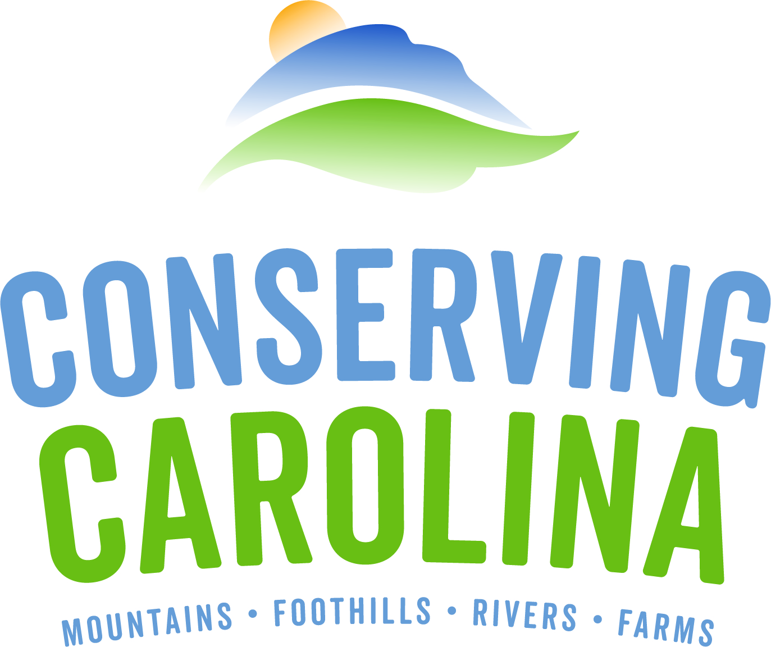
AmeriCorps Project Conserve

Member Application 2018-2019

The applications deadline has been extended for some positions. Positions will be open until filled, so please apply ASAP to be considered.

For questions, please contact Amy Stout at 828-697-5777, ext. 217 projectconserve@conservingcarolina.org

Your Legal Name: Click to enter text. Nickname: Click to enter text.
Last 4 digits of Social Security Number: Click to enter text. Date of Birth: Click to enter text.

Permanent Mailing Address: Click to enter text.
Telephone: Click to enter text. E-mail: Click to enter text.

Current Mailing Address (if different from above): Click to enter text.
Telephone: Click to enter text. E-mail: Click to enter text.

- I can be contacted at this address/phone until: Click to enter text.
- The best time of day to reach me at the above address/phone is: Click to enter text.
- List at least one additional phone number where messages may be left for you: Click to enter text.

The policy and intent of CMLC and AmeriCorps Project Conserve are to provide equal employment opportunity to all persons regardless of race, color, religion, national origin, marital status, political affiliation, sexual orientation or gender identity, disability, sex or age, or other status protected by law. Individuals with disabilities are encouraged to apply. AmeriCorps Project Conserve will provide reasonable accommodations to individuals with known mental / physical disabilities.

AmeriCorps Project Conserve is administered by Conserving Carolina and funded by the Corporation for National and Community Service, the North Carolina Commission on Volunteerism and Community Service in the office of Governor Roy Cooper, and the critical support of our host sites and community partners.

SURVEY

Please answer all of the following questions:
Are you a U.S. citizen, national, or lawful permanent resident of the U.S? Yes ☐ No ☐
Are you available for the duration of time from 09/01/18 to 07/31/19? Yes ☐ No ☐
Are you able to perform all functions of the position described? Yes ☐ No ☐
Are you willing to submit to a Criminal History Check? Yes ☐ No ☐
Have you ever been convicted of a felony? Yes ☐ No ☐
If “YES,” please explain: Click to enter text.
How did you hear about Project Conserve? (i.e. specific website name, from a friend, etc.): Click to enter text.

OPTIONAL INFORMATION
The information in the section below is optional (for demographic data only) and will not be used in making selection decisions. Describe your ethnic background, check all that apply:

☐African American
☐Alaskan Native
☐Asian American
☐Hispanic/Latino
☐Middle Eastern
☐Indian Subcontinent
☐Native American Indian
☐Pacific Islander
☐White/Caucasian
☐Other: Click to enter text.

2018 – 2019 POSITION SELECTION AND RANKING

Please rank the positions you are applying for below from first choice #1 to last choice.

You may apply for as many positions as you wish, but please check the Project Conserve website https://conservingcarolina.org/americorps/project-conserve/join-project-conserve/open-positions/

for an up-to-date listing of open positions.

Full Time (1700 hours) Positions:
Enter rank Foothills Equestrian Nature Center (FENCE) AmeriCorps Environmental Education Associate
Enter rank Mountain Sun Community School AmeriCorps Transylvania County Natural Learning Initiative Coordinator
Enter rank Polk County Recreation Department AmeriCorps Trails Coordinator
Enter rank Transylvania County Cooperative Extension……..AmeriCorps Education and Volunteer Associate
Enter rank Town of Lake Lure AmeriCorps Trails Coordinator

Half Time (900 hours) Positions:
Enter rank Polk Co. Office of Agricultural Economic Dev’t AmeriCorps Farm & Consumer Outreach Specialist
Enter rank Mountain Roots AmeriCorps Outdoor Education Instructor

AMERICORPS SERVICE
In the space below, describe any previous AmeriCorps service. In the reflection section, elaborate on why you decided to get involved and how you benefited from the service.

PREVIOUS AMERICORPS TERMS

Have you previously served in AmeriCorps? ☐ NO ☐ YES

If “yes,” check all that apply:
☐ AmeriCorps *VISTA ☐ AmeriCorps *NCCC ☐ AmeriCorps *State or National Program

DATES OF INVOLVEMENT: From (mo/yr): Click to enter a date. To (mo/yr): Click to enter a date.
Did you complete your term of service? ☐YES ☐ NO
Program Name: Click to enter text. Location: Click to enter text.
Contact Person: Click to enter text. Phone: Click to enter text. Email: Click to enter text.

Description of Involvement and Reflection on Experience: Click to enter text.

COMMUNITY SERVICE
In the space below, describe your involvement in service. How have you reached out to help others, your community, or another community? In the reflection section, elaborate on why you decided to get involved and how you benefited from the service.

1. DATES OF INVOLVEMENT: From (mo/yr): Click to enter a date. To (mo/yr): Click to enter a date.
Hours / Month: Click here to enter text.
Organization Name: Click here to enter text. Location: Click here to enter text.
Description of Involvement and Reflection on Experience: Click to enter text.

2. DATES OF INVOLVEMENT: From (mo/yr): Click to enter a date. To (mo/yr): Click to enter a date.
Hours / Month: Click here to enter text.
Organization Name: Click here to enter text. Location: Click here to enter text.
Description of Involvement and Reflection on Experience: Click to enter text.

APPLICANT SKILLS & EXPERIENCE:
Please indicate those areas in which you have had significant experience or training.

☐ Volunteer Coordination
☐ Community Outreach
☐ Communications
☐ HTML / Web Design
☐ Writing
☐Public Speaking
☐Group Leadership
☐ Youth Education
☐Geographic Information
Systems (GIS)
☐Water Quality
Monitoring
☐ Land / Natural Resource
Management
☐Trail Building
☐ Plant ID
☐ Other: Click here to enter text.

REFERENCES
Please list TWO professional references (please let them know we may be contacting them):

#1 – Name: Click to enter text. Relationship: Click to enter text.

Address: Click to enter text. City/State: Click to enter text.

Telephone: Click to enter text. Email: Click to enter text.

How long has this person known you? Click to enter text.

#2 – Name: Click to enter text. Relationship: Click to enter text.

Address: Click to enter text. City/State: Click to enter text.

Telephone: Click to enter text. Email: Click to enter text.

How long has this person known you? Click to enter text.

SHORT ANSWERS
Please answer the following questions.

- Please describe why you want to serve in the AmeriCorps Project Conserve program.

Click here to enter text.

- Please describe any specific relevant education, experience, or skills that you have that would be an asset to the AmeriCorps program and the western North Carolina community and environment.

Click here to enter text.

- What are your future career goals?

Click here to enter text.

- Please describe your community service experience and how it has prepared you for an AmeriCorps position.

Click here to enter text.

- What conservation issue(s) are of personal interest to you?

Click here to enter text.

A Point to Ponder… Project Conserve is a program that serves the community and emphasizes building strong partnerships. Please recognize that by applying and accepting a position, you would be willing to serve the FULL eleven months. If you cannot commit to the full term, then please do not apply. Organizations are not able to rehire for the positions until the following year.

